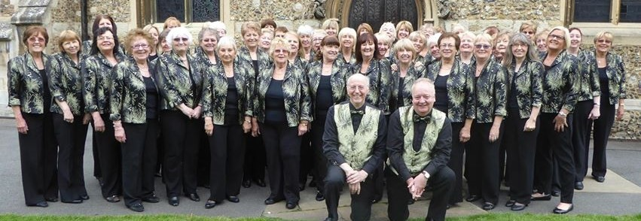

Registered Charity No 1085887

Email: [info@swiftsingers.co.uk](mailto:info@swiftsingers.co.uk)

Phone: 01245 320071

*Information*

*Welcome*

***Swift Singers***

# Swift Singers

# March 2022

*Welcome*

On behalf of the Committee, we would like to welcome you to the Swift Singers and hope you will enjoy singing with us and being part of a friendly and active Choir.

The Choir is a registered charity with a Committee elected annually in February at the AGM. The Committee meets on a regular basis to discuss business and also to arrange concerts. Each section of the Choir has a Leader who will be happy to help with any queries or problems. Your section Leader can pass any comments you may have to the Committee.

We have various social events during the year. Although you are not obliged to attend these events, we have a great time and get to know people better than we are able to at rehearsals when our minds are on the music.

Please feel free to ask anyone in the choir for assistance. We have a New Member Liaison Officer whom we hope you have already met and a librarian who will provide you with loaned music and then your own copies once you have paid subs.

We are pleased to be back rehearsing again; we are adhering to all government Covid guidelines along with a few enhanced measures. We ask all members to be double vaccinated.

We have a Website that you might find useful: [www.swiftsingers.co.uk](http://www.swiftsingers.co.uk/)

Practice tracks are uploaded to the members area of the website regularly.

You can also find us on Facebook.

*Membership*

To keep our membership records up to date it would be appreciated if you could complete and return the enclosed slip to the new member liaison officer, within 4 weeks of first attending rehearsals. At the same time, please pay your first terms subs to the treasurer. You will then be issued with a set of music which will be added to as necessary.

We also have a social WhatApp group and Facebook page along with a Choir Website [www.swiftsingers.co.uk](http://www.swiftsingers.co.uk) and run social events several times a year.

We run a 100 club which raises funds for the choir and the members can win cash prizes. To pay for MEMBERSHIP TO THE 100 CLUB (which is optional), again you should pay this directly to our bank account below. These payments are made twice a year, during May and November and cost £6 for one number in the draw each month, £12 for two numbers, £18 for three numbers, £24 for four numbers and £30 for five numbers.  Maximum 5 numbers permitted.  Again, it is important you put a reference of your full Christian and Surname and "100 Club".

The Bank details for these payments are:

Sort Code 20-19-95

Account No. 30732524

Account Name SWIFT SINGERS NO. 2 ACCOUNT

*Fundraising*

We regularly hold events to raise money for the choir. This enables us to continue to buy music and put on concerts. We also have an easy fundraising page which anyone can sign up to and raise money for the choir when they shop online.

Please consider signing up for this and encourage your family and friends to support the choir through this site. In our first year of using Easy fundraising, we raised nearly £600 for the choir which we have used to expand our staging.

To sign up, go to [www.easyfundraising.co.uk](http://www.easyfundraising.co.uk/) and search for Swift Singers as your chosen charity.*The Committee*

The officers of the committee are:

Philippa Marshall Chairperson/Choir leader  
Chris Hutson Treasurer/Ticket Sales  
Janice Pearson Secretary/Catering/Mezzo section leader

Other committee members are:

Jean Chasmer Concert Secretary/ Ticket Sales / Choir Leader/ Promotion

Catherine Quinn Facebook/ Website / Promotion/ Music Librarian  
/ Co-Alto section leader

Lesley Turley Website/ Promotion/ Music Librarian /Co-Alto Section leader/ Email

Karen Latham Publicity / Advertising / Promotion

Jane Hyde Soprano Section Leader/Promotion / Social Secretary/ Treasurer in training/Fundraising

Lynda Coley Publicity

Pam Sterry New Membership Liaison

Gill Owen (Co-optd) Uniform/Promotion/Staging

*Useful Information*

**Derrick Thompson  
Accompanist**

**Tim Rhys-Morgan  
Musical Director**

The Choir is made up of three sections: 1st Soprano, Mezzo Soprano and Alto. The Altos split into 2 parts for some of our pieces.

The Musical Director will arrange to listen to your voice in private after a few weeks to help decide which section is best for your voice.

Once you have been assigned to a section, please get to know your singing colleagues and have fun.

*Rehearsals*

We meet at the Village Hall, Hullbridge Road on Tuesday evenings commencing at 8.15pm prompt, finishing at 9. 45pm.There are no rehearsals in August. Additional rehearsals are sometimes arranged prior to a Concert and are usually on a Sunday evening.

We sometimes sit within our sections for rehearsals but may be mixed up to give us a better appreciation of the other parts and allow us to become confident in singing against them. When we are mixed, we all sit with a singing buddy of the same section for moral support.*Music*All music provided to you remains the property of the Swift Singers and we ask that only pencil is used to mark music, **no ink or high- lighter pen.**

Please note it is illegal to photocopy music. If you are missing music or lose a piece of music, please speak to the Librarian who will arrange a replacement.

Although provision of your music is included in your subscription, any replacements will need to be paid for.

*Concerts*  
It is the Swift Singers’ policy that new members must attend a total of **24** rehearsals before participating in a concert in order to give plenty of time to learn the music. In order to take part in any concert, all members are expected to attend **8 out of the last 12** rehearsals, and **2 out of the last 3**, before each concert. Please check with your section Leader if you are unsure about qualification.

All members are expected to learn all the **Music and Words** for each concert.

# Subscriptions

To pay your MEMBERSHIP SUBSCRIPTIONS, which are currently £150 per annum, please pay these directly into our bank account in three lots of £50 during January, April and September each year.  It is important you put a reference of your full Christian and Surname and "Subs".

The Bank details for these payments are:  
Sort Code  20-19-95  
Account No.         10851906  
Account Name SWIFT SINGERS

As we are a registered charity these subscriptions qualify for Gift Aid. A Gift Aid Declaration is included with this pack for completion if you are a taxpayer. The additional revenue received by the Swift Singers from this scheme enables us to keep our subscription charge low, so please complete the form if you can. You can speak to our Treasurer who will give you any advice you may require.*Uniform*

Our current uniform for concerts is black trousers with a black/gold jacket and black t-shirt. We also have a black musical scarf that we sometimes wear instead of the jacket for a more informal appearance.

The jacket will be provided to you as required for each concert. You may be given one on permanent loan but can be asked to lend this to another choir member if you are not participating in a concert. The jacket is not machine washable and should be dry cleaned when necessary.

We make a charge of £3.50 for a musical scarf which is yours to keep if you decide to leave the choir. We ask you to provide your own tailored black trousers (no leggings or jeans) and a short sleeved, scoop neck black t shirt. Once you qualify for a concert, the uniform co-ordinator will ensure you have all the items you require.

Please wear black shoes and black tights/socks.